Operations Management, 10e, Global Edition (Heizer/Render)
Chapter 6 Managing Quality

1) Managers at Arnold Palmer Hospital take quality so seriously that the hospital typically is a national leader in several quality areas–so that continuous improvement is no longer necessary.
Answer: FALSE
Diff: 2
Topic: Global company profile
Objective: LO6-1

2) An improvement in quality must necessarily increase costs.
Answer: FALSE
Diff: 1
Topic: Quality and strategy
Objective: LO6-1

3) For most, if not all organizations, quality is a tactical rather than a strategic issue.
Answer: FALSE
Diff: 2
Topic: Quality and strategy
Objective: LO6-1

4) The definition of quality adopted by The American Society for Quality is a customer-oriented definition.
Answer: TRUE
Diff: 1
Topic: Defining quality
Objective: LO6-1

5) Conforming to standards is the focus of the product-based definition of quality.
Answer: FALSE
Diff: 2
Topic: Defining quality
Objective: LO6-1

6) Internal failure costs are associated with scrap, rework, and downtime.
Answer: TRUE
Diff: 1
Topic: Defining quality
Objective: LO6-1

7) Philip Crosby is credited with both of these quality catch-phrases: "quality is free" and "zero defects."
Answer: TRUE
Diff: 1
Topic: Defining quality
Objective: LO6-1
8) Deming's writings on quality tend to focus on the customer and on fitness for use, unlike Juran's work that is oriented toward meeting specifications.
Answer: FALSE
Diff: 2
Topic: Defining quality
Objective: LO6-1

9) Improved quality can increase profitability via flexible pricing.
Answer: TRUE
Diff: 2
Topic: Defining quality
Objective: LO6-1

10) ISO 9000 has evolved from a set of quality assurance standards toward a quality management system.
Answer: TRUE
Diff: 2
Topic: International quality standards
Objective: LO6-2

11) Quality is mostly the business of the quality control staff, not ordinary employees.
Answer: FALSE
Diff: 2
Topic: Total quality management
Objective: LO6-1

12) TQM is important because quality influences all of the ten decisions made by operations managers.
Answer: TRUE
Diff: 2
Topic: Total quality management
Objective: LO6-1

13) The phrase Six Sigma has two meanings. One is statistical, referring to an extremely high process capability; the other is a comprehensive system for achieving and sustaining business success.
Answer: TRUE
Diff: 2
Topic: Total quality management
Objective: LO6-3

14) Continuous improvement is based on the philosophy that any aspect of an organization can be improved.
Answer: TRUE
Diff: 2
Topic: Total quality management
Objective: LO6-1
15) Kaizen is similar to TQM in that both are focused on continuous improvement.
Answer: TRUE
Diff: 2
Topic: Total quality management
Objective: LO6-1

16) The Japanese use the term "poka-yoke" to refer to continuous improvement.
Answer: FALSE
Diff: 2
Topic: Total quality management
AACSB: Multicultural and Diversity
Objective: LO6-1

17) Quality circles empower employees to improve productivity by finding solutions to work-related problems in their work area.
Answer: TRUE
Diff: 2
Topic: Total quality management
AACSB: Communication
Objective: LO6-1

18) Benchmarking requires the comparison of your firm to other organizations; it is not appropriate to benchmark by comparing one of your divisions to another of your divisions.
Answer: FALSE
Diff: 2
Topic: Total quality management
Objective: LO6-4

19) Line employees need the knowledge of TQM tools.
Answer: TRUE
Diff: 1
Topic: Total quality management
Objective: LO6-1

20) One of the ways that Just-In-Time (or JIT) influences quality is that by reducing inventory, bad quality is exposed.
Answer: TRUE
Diff: 2
Topic: Total quality management
Objective: LO6-1

21) The quality loss function indicates that costs related to poor quality are low as long as the product is within acceptable specification limits.
Answer: FALSE
Diff: 2
Topic: Total quality management
Objective: LO6-1
22) Pareto charts are a graphical way of identifying the few critical items from the many less important ones.
Answer: TRUE
Diff: 2
Topic: Tools of TQM
Objective: LO6-6

23) A cause-and-effect diagram helps identify the source of a problem.
Answer: TRUE
Diff: 2
Topic: Tools of TQM
Objective: LO6-6

24) Source inspection is inferior to inspection before costly operations.
Answer: FALSE
Diff: 2
Topic: The role of inspection
Objective: LO6-5

25) Of the several determinants of service quality, access is the one that relates to keeping customers informed in language they can understand.
Answer: FALSE
Diff: 2
Topic: TQM in services
Objective: LO6-5

26) High-quality products and services are the most profitable.
Answer: TRUE
Diff: 1
Topic: Defining quality
Objective: LO6-1

27) Which of the following statements regarding Arnold Palmer Hospital is false?
A) The hospital uses a wide range of quality management techniques.
B) The culture of quality at the hospital includes employees at all levels.
C) The hospital scores very highly in national studies of patient satisfaction.
D) The hospital's high quality is measured by low readmission rates, not patient satisfaction.
E) The design of patient rooms, even wall colors, reflects the hospital's culture of quality.
Answer: D
Diff: 2
Topic: Global company profile
Objective: no LO
28) Arnold Palmer Hospital uses which of the following quality management techniques?
A) Pareto charts
B) flow charts
C) benchmarking
D) Just-in-Time
E) The hospital uses all of the above techniques.
Answer: E
Diff: 1
Topic: Global company profile
Objective: no LO

29) Companies with the highest levels of quality are almost how many times more productive than their competitors with the lowest quality levels?
A) 2x
B) 3x
C) 4x
D) 5x
E) None of the above, quality has no impact on productivity (units/labor hr)
Answer: D
Diff: 2
Topic: Quality and strategy
Objective: LO6-1

30) A successful quality strategy features which of the following steps?
A) organization environment that fosters quality
B) understanding the principles of quality
C) engaging employees in the necessary activities for quality implementation
D) A and C
E) A, B, and C
Answer: E
Diff: 2
Topic: Quality and strategy
Objective: LO6-1

31) Which of the following statements best describes the relationship between quality management and product strategy?
A) Product strategy is set by top management; quality management is an independent activity.
B) Quality management is important to the low-cost product strategy, but not to the response or differentiation strategies.
C) High quality is important to all three strategies, but it is not a critical success factor.
D) Managing quality helps build successful product strategies.
E) Companies with the highest measures of quality were no more productive than other firms.
Answer: D
Diff: 2
Topic: Defining quality
Objective: LO6-1
32) "Quality is defined by the customer" is
A) an unrealistic definition of quality
B) a user-based definition of quality
C) a manufacturing-based definition of quality
D) a product-based definition of quality
E) the definition proposed by the American Society for Quality
Answer: B
Diff: 2
Topic: Defining quality
Objective: LO6-1

33) "Making it right the first time" is
A) an unrealistic definition of quality
B) a user-based definition of quality
C) a manufacturing-based definition of quality
D) a product-based definition of quality
E) the definition proposed by the American Society for Quality
Answer: C
Diff: 2
Topic: Defining quality
Objective: LO6-1

34) Three broad categories of definitions of quality are
A) product quality, service quality, and organizational quality
B) user-based, manufacturing-based, and product-based
C) internal, external, and prevention
D) low-cost, response, and differentiation
E) Pareto, Shewhart, and Deming
Answer: B
Diff: 1
Topic: Defining quality
Objective: LO6-1

35) According to the manufacturing-based definition of quality,
A) quality is the degree of excellence at an acceptable price and the control of variability at an acceptable cost
B) quality depends on how well the product fits patterns of consumer preferences
C) even though quality cannot be defined, you know what it is
D) quality is the degree to which a specific product conforms to standards
E) quality lies in the eyes of the beholder
Answer: D
Diff: 2
Topic: Defining quality
Objective: LO6-1
36) The role of quality in limiting a firm's product liability is illustrated by
A) ensuring that contaminated products such as impure foods do not reach customers
B) ensuring that products meet standards such as those of the Consumer Product Safety Act
C) designing safe products to limit possible harm to consumers
D) using processes that make products as safe or as durable as their design specifications call for
E) All of the above are valid.
Answer: E
Diff: 1
Topic: Defining quality
AACSB: Ethical Reasoning
Objective: LO6-1

37) Which of the following is not one of the major categories of costs associated with quality?
A) prevention costs
B) appraisal costs
C) internal failures
D) external failures
E) None of the above; they are all major categories of costs associated with quality.
Answer: E
Diff: 2
Topic: Defining quality
Objective: LO6-1

38) All of the following costs are likely to decrease as a result of better quality except
A) customer dissatisfaction costs
B) inspection costs
C) scrap costs
D) warranty and service costs
E) maintenance costs
Answer: E
Diff: 2
Topic: Defining quality
Objective: LO6-1

39) Quality can improve profitability by reducing costs. Which of the following is not an aspect of reduced costs by quality improvements?
A) flexible pricing
B) increased productivity
C) lower rework and scrap costs
D) lower warranty costs
E) All of the above are aspects of reduced costs by quality improvements.
Answer: A
Diff: 2
Topic: Defining quality
Objective: LO6-1
40) GE's recall of 3.1 million dishwashers cost the company more in repairs than the value of the actual dishwashers. This is an example of which quality principle?
A) quality is free
B) internal failure costs
C) appraisal costs
D) cost of poor quality is underestimated
E) prevention costs
Answer: D
Diff: 2
Topic: Defining quality
Objective: LO6-1

41) Which of the following statements is not true?
A) Self-promotion is not a substitute for quality products.
B) Inferior products harm a firm's profitability and a nation's balance of payments.
C) Product liability transfers from the manufacturer to the retailer once the retailer accepts delivery of the product.
D) Quality–be it good or bad–will show up in perceptions about a firm's new products, employment practices, and supplier relations.
E) Legislation such as the Consumer Product Safety Act sets and enforces product standards by banning products that do not reach those standards.
Answer: C
Diff: 2
Topic: Defining quality
Objective: LO6-1

42) "Employees cannot produce goods that on average exceed the quality of what the process is capable of producing" expresses a basic element in the writings of
A) Vilfredo Pareto
B) Armand Feigenbaum
C) Joseph M. Juran
D) W. Edwards Deming
E) Philip B. Crosby
Answer: D
Diff: 2
Topic: Defining quality
Objective: LO6-1

43) "Quality Is Free," meaning that the costs of poor quality have been understated, is the work of
A) W. Edwards Deming
B) Joseph M. Juran
C) Philip B. Crosby
D) Crosby, Stills, and Nash
E) Armand Feigenbaum
Answer: C
Diff: 2
Topic: Defining quality
Objective: LO6-1
44) The philosophy of zero defects is
A) the result of Deming's research
B) unrealistic
C) prohibitively costly
D) an ultimate goal; in practice, 1 to 2% defects is acceptable
E) consistent with the commitment to continuous improvement
Answer: E
Diff: 2
Topic: Total quality management
Objective: LO6-5

45) Based on his 14 Points, Deming is a strong proponent of
A) inspection at the end of the production process
B) an increase in numerical quotas to boost productivity
C) looking for the cheapest supplier
D) training and knowledge
E) all of the above
Answer: D
Diff: 2
Topic: Total quality management
Objective: LO6-5

46) Stakeholders who are affected by the production and marketing of poor quality products include
A) stockholders, employees, and customers
B) suppliers and creditors, but not distributors
C) only stockholders, creditors, and owners
D) suppliers and distributors, but not customers
E) only stockholders and organizational executives and managers
Answer: A
Diff: 2
Topic: Defining quality
AACSB: Ethical Reasoning
Objective: LO6-1
47) PDCA, developed by Shewhart, stands for which of the following?
A) Plan-Do-Check-Act
B) Plan-Develop-Check-Accept
C) Problem-Develop Solution- Check- Act
D) Problem-Do-Continue-Act
E) none of the above
Answer: A
Diff: 2
Topic: Total quality management
Objective: LO6-5

48) PDCA is most often applied in regard to which aspect of TQM?
A) Six Sigma
B) Employee Empowerment
C) Continuous Improvement
D) Benchmarking
E) JIT
Answer: C
Diff: 2
Topic: Total quality management
Objective: LO6-5

49) A Three Sigma program has how many defects per million?
A) 34
B) 3
C) 3 times the standard deviation
D) 2700
E) 1500
Answer: D
Diff: 2
Topic: Total quality management
AACSB: Analytic Skills
Objective: LO6-3

50) A Six Sigma program has how many defects per million?
A) 3.4
B) 34
C) 1000
D) 6 times the standard deviation
E) none of the above
Answer: A
Diff: 2
Topic: Total quality management
AACSB: Analytic Skills
Objective: LO6-3
51) A hospital benchmarked against Ferrari Racing in an effort to
A) improve patient handoff quality
B) increase surgery prep time
C) lengthen surgery duration
D) reduce the number of doctors
E) all of the above
Answer: A
Diff: 2
Topic: Total quality management
Objective: LO6-4

52) One of Britain's largest children's hospitals working with Ferrari Racing is an example of
A) internal benchmarking
B) external benchmarking
C) Taguchi concepts
D) employee empowerment
E) corporate responsibility
Answer: B
Diff: 2
Topic: Total quality management
Objective: LO6-4

53) Regarding the quality of design, production, and distribution of products, an ethical requirement for management is to
A) determine whether any of the organization's stakeholders are violated by poor quality products
B) gain ISO 14000 certification for the organization
C) obtain a product safety certificate from the Consumer Product Safety Commission
D) have the organization's legal staff write disclaimers in the product instruction booklets
E) compare the cost of product liability to the external failure cost
Answer: A
Diff: 2
Topic: Defining quality
AACSB: Ethical Reasoning
Objective: LO6-1

54) If 1 million passengers pass through the St. Louis Airport with checked baggage each month, a successful Six Sigma program for baggage handling would result in how many passengers with misplaced luggage?
A) 3.4
B) 6.0
C) 34
D) 2700
E) 6 times the monthly standard deviation of passengers
Answer: A
Diff: 2
Topic: Total quality management
AACSB: Analytic Skills
Objective: LO6-3
55) Which of the following is true about ISO 14000 certification?
A) It is not a prerequisite for ISO 9000 certification.
B) It deals with environmental management.
C) It offers a good systematic approach to pollution prevention.
D) One of its core elements is life-cycle assessment.
E) All of the above are true.
Answer: E
Diff: 2
Topic: International quality standards
Objective: LO6-2

56) Suppose that a firm has historically been achieving "three-sigma" quality. If the firm later changes its quality management practices such that it begins to achieve "six-sigma" quality, which of the following phenomena will result?
A) The average number of defects will be cut in half.
B) The specification limits will be moved twice as far from the mean.
C) The average number of defects will be cut by 99.9997%.
D) The average number of defects will be cut by 99.87%.
E) The average number of defects will be cut by 99.73%.
Answer: D
Diff: 3
Topic: Total quality management
AACSB: Analytic Skills
Objective: LO6-3

57) To become ISO 9000 certified, organizations must
A) document quality procedures
B) have an onsite assessment
C) have an ongoing series of audits of their products or service
D) all of the above
E) none of the above
Answer: D
Diff: 2
Topic: International quality standards
Objective: LO6-2

58) Total quality management emphasizes
A) the responsibility of the quality control staff to identify and solve all quality-related problems
B) a commitment to quality that goes beyond internal company issues to suppliers and customers
C) a system where strong managers are the only decision makers
D) a process where mostly statisticians get involved
E) ISO 14000 certification
Answer: B
Diff: 2
Topic: Total quality management
Objective: LO6-1
59) A successful TQM program incorporates all of the following except
A) continuous improvement
B) employee involvement
C) benchmarking
D) centralized decision-making authority
E) None of the above; a successful TQM program incorporates all of the above.
Answer: D
Diff: 2
Topic: Total quality management
Objective: LO6-5

60) "Kaizen" is a Japanese term meaning
A) a foolproof mechanism
B) just-in-time (JIT)
C) a fishbone diagram
D) setting standards
E) continuous improvement
Answer: E
Diff: 1
Topic: Total quality management
AACSB: Multicultural and Diversity
Objective: LO6-1

61) Which of the following statements regarding "Six Sigma" is true?
A) The term has two distinct meanings–one is statistical; the other is a comprehensive quality system.
B) Six Sigma means that about 94 percent of a firm's output is free of defects.
C) The Six Sigma program was developed by Toyota in the 1970's.
D) The Six Sigma program is for manufacturing firms, and is not applicable to services.
E) Six Sigma certification is granted by the International Standards Organization (ISO).
Answer: A
Diff: 2
Topic: Total quality management
Objective: LO6-3

62) Quality circles members are
A) paid according to their contribution to quality
B) external consultants designed to provide training in the use of quality tools
C) always machine operators
D) all trained to be facilitators
E) None of the above; all of the statements are false.
Answer: E
Diff: 2
Topic: Total quality management
Objective: LO6-5
63) Techniques for building employee empowerment include
A) building communication networks that include employees
B) developing open, supportive supervisors
C) moving responsibility from both managers and staff to production employees
D) building high-morale organizations
E) All of the above are techniques for employee empowerment.
Answer: E
Diff: 2
Topic: Total quality management
Objective: LO6-5

64) Building high-morale organizations and building communication networks that include employees are both elements of
A) ISO 9000 certification
B) Six Sigma certification
C) employee empowerment
D) Taguchi methods
E) the tools of TQM
Answer: C
Diff: 2
Topic: Total quality management
AACSB: Communication
Objective: LO6-5

65) The process of identifying other organizations that are best at some facet of your operations and then modeling your organization after them is known as
A) continuous improvement
B) employee empowerment
C) benchmarking
D) copycatting
E) patent infringement
Answer: C
Diff: 2
Topic: Total quality management
Objective: LO6-4

66) ISO 9000 seeks standardization in terms of
A) products
B) production procedures
C) suppliers' specifications
D) procedures to manage quality
E) all of the above
Answer: D
Diff: 2
Topic: International quality standards
Objective: LO6-2
67) Costs of dissatisfaction, repair costs, and warranty costs are elements of cost in the
A) Taguchi Loss Function
B) Pareto chart
C) ISO 9000 Quality Cost Calculator
D) process chart
E) none of the above
Answer: A
Diff: 2
Topic: Total quality management
Objective: LO6-5

68) A quality loss function includes all of the following costs except
A) the cost of scrap and repair
B) the cost of customer dissatisfaction
C) inspection, warranty, and service costs
D) sales costs
E) costs to society
Answer: D
Diff: 2
Topic: Tools of TQM
Objective: LO6-6

69) Pareto charts are used to
A) identify inspection points in a process
B) outline production schedules
C) organize errors, problems, or defects
D) show material flow
E) all of the above
Answer: C
Diff: 2
Topic: Tools of TQM
Objective: LO6-6

70) The "four Ms" of cause-and-effect diagrams are
A) material, machinery/equipment, manpower, and methods
B) material, methods, men, and mental attitude
C) named after four quality experts
D) material, management, manpower, and motivation
E) none of the above
Answer: A
Diff: 2
Topic: Tools of TQM
Objective: LO6-6
71) Among the tools of TQM, the tool ordinarily used to aid in understanding the sequence of events through which a product travels is a
A) Pareto chart
B) process chart
C) check sheet
D) Taguchi map
E) poka-yoke
Answer: B
Diff: 2
Topic: Tools of TQM
Objective: LO6-6

72) The process improvement technique that sorts the "vital few" from the "trivial many" is
A) Taguchi analysis
B) Pareto analysis
C) benchmarking
D) Deming analysis
E) Yamaguchi analysis
Answer: B
Diff: 2
Topic: Tools of TQM
Objective: LO6-6

73) A production manager at a pottery factory has noticed that about 70 percent of defects result from impurities in raw materials, 15 percent result from human error, 10 percent from machine malfunctions, and 5 percent from a variety of other causes. This manager is most likely using
A) a Pareto chart
B) a scatter diagram
C) a Taguchi loss function
D) a cause and effect diagram
E) a flow chart
Answer: A
Diff: 1
Topic: Tools of TQM
Objective: LO6-6

74) A customer service manager at a retail clothing store has collected numerous customer complaints from the forms they fill out on merchandise returns. To analyze trends or patterns in these returns, she has organized these complaints into a small number of sources or factors. This is most closely related to the __________ tool of TQM.
A) Taguchi loss function
B) cause and effect diagram
C) scatter diagram
D) histogram
E) process control chart
Answer: B
Diff: 1
Topic: Tools of TQM
Objective: LO6-6
75) A manager tells her production employees, "It's no longer good enough that your work fall anywhere within the specification limits. I need your work to be as close to the target value as possible." Her thinking is reflective of
A) internal benchmarking
B) Six Sigma
C) ISO 9000
D) Taguchi concepts
E) process control charts
Answer: D
Diff: 2
Topic: Tools of TQM
Objective: LO6-6

76) A fishbone diagram is also known as a
A) cause-and-effect diagram
B) poka-yoke diagram
C) Kaizen diagram
D) Kanban diagram
E) Taguchi diagram
Answer: A
Diff: 1
Topic: Tools of TQM
Objective: LO6-6

77) If a sample of parts is measured and the mean of the measurements is outside the control limits, the process is
A) in control, but not capable of producing within the established control limits
B) out of control and the process should be investigated for assignable variation
C) within the established control limits with only natural causes of variation
D) monitored closely to see if the next sample mean will also fall outside the control limits
E) none of the above
Answer: B
Diff: 2
Topic: Tools of TQM
Objective: LO6-6

78) A quality circle holds a brainstorming session and attempts to identify the factors responsible for flaws in a product. Which tool do you suggest they use to organize their findings?
A) Ishikawa diagram
B) Pareto chart
C) process chart
D) control charts
E) activity chart
Answer: A
Diff: 2
Topic: Tools of TQM
AACSB: Communication
Objective: LO6-6
79) When a sample measurement falls inside the control limits, it means that
A) each unit manufactured is good enough to sell
B) the process limits cannot be determined statistically
C) the process output exceeds the requirements
D) if there is no other pattern in the samples, the process is in control
E) the process output does not fulfill the requirements
Answer: D
Diff: 2
Topic: Tools of TQM
Objective: LO6-6

80) Which of the following is false regarding control charts?
A) Values above the upper control limits always imply that the product's quality is exceeding expectations.
B) Control charts are built so that new data can be quickly compared to past performance data.
C) Control charts graphically present data.
D) Control charts plot data over time.
E) None of the above is false.
Answer: A
Diff: 2
Topic: Tools of TQM
Objective: LO6-6

81) The goal of inspection is to
A) detect a bad process immediately
B) add value to a product or service
C) correct deficiencies in products
D) correct system deficiencies
E) all of the above
Answer: A
Diff: 2
Topic: The role of inspection
Objective: LO6-5

82) Which of the following is not a typical inspection point?
A) upon receipt of goods from your supplier
B) during the production process
C) before the product is shipped to the customer
D) at the supplier's plant while the supplier is producing
E) after a costly process
Answer: E
Diff: 2
Topic: The role of inspection
Objective: LO6-5
83) A good description of "source inspection" is inspecting
A) materials upon delivery by the supplier
B) the goods at the production facility before they reach the customer
C) the goods as soon as a problem occurs
D) goods at the supplier's plant
E) one's own work, as well as the work done at the previous work station
Answer: E
Diff: 2
Topic: The role of inspection
Objective: LO6-5

84) "Poka-yoke" is the Japanese term for
A) card
B) foolproof
C) continuous improvement
D) fishbone diagram
E) just-in-time production
Answer: B
Diff: 2
Topic: The role of inspection
AACSB: Multicultural and Diversity
Objective: LO6-5

85) What refers to training and empowering frontline workers to solve a problem immediately?
A) just-in-time
B) poka-yoke
C) benchmarking
D) kaizen
E) service recovery
Answer: E
Diff: 1
Topic: TQM in services
Objective: LO6-5

86) A recent consumer survey conducted for a car dealership indicates that, when buying a car, customers are primarily concerned with the salesperson's ability to explain the car's features, the salesperson's friendliness, and the dealer's honesty. The dealership should be especially concerned with which determinants of service quality?
A) communication, courtesy, and credibility
B) competence, courtesy, and security
C) competence, responsiveness, and reliability
D) communication, responsiveness, and reliability
E) understanding/knowing customer, responsiveness, and reliability
Answer: A
Diff: 2
Topic: TQM in services
AACSB: Communication
Objective: LO6-5
87) Marketing issues such as advertising, image, and promotion are important to quality because
A) they define for consumers the tangible elements of a service
B) the intangible attributes of a product (including any accompanying service) may not be defined by the consumer
C) they educate consumers on how to use the product
D) they make the product seem more valuable than it really is
E) they raise expenses and therefore decrease profitability
Answer: B
Diff: 2
Topic: TQM in services
Objective: LO6-5

88) Which of the determinants of service quality involves having the customer's best interests at heart?
A) access
B) courtesy
C) credibility
D) responsiveness
E) tangibles
Answer: C
Diff: 2
Topic: TQM in services
Objective: LO6-5

89) Which of the determinants of service quality involves performing the service right the first time?
A) access
B) courtesy
C) credibility
D) reliability
E) responsiveness
Answer: D
Diff: 2
Topic: TQM in services
Objective: LO6-5

90) Arnold Palmer Hospital uses __________ to seek new ways to reduce readmission rates.
Answer: continuous improvement
Diff: 1
Topic: Global company profile
Objective: no LO

91) __________ costs result from production of defective parts or services before delivery to the customer.
Answer: Internal failure
Diff: 2
Topic: Defining quality
Objective: LO6-1
92) __________ is a set of environmental standards developed by the International Standards Organization.
Answer: ISO 14000
Diff: 2
Topic: Defining quality
AACSB: Ethical Reasoning
Objective: LO6-1

93) The work by __________ regarding how people learn from each other's successes led to the field of cross-functional teamwork.
Answer: Armand Feigenbaum
Diff: 2
Topic: Defining quality
Objective: LO6-1

94) Not only customers, but stockholders, suppliers, and others, are among the __________ whose values must be protected in making ethical decisions concerning the quality of products.
Answer: stakeholders
Diff: 1
Topic: Defining quality
AACSB: Ethical Reasoning
Objective: LO6-1

95) __________ is the Japanese word for the ongoing process of incremental improvement.
Answer: Kaizen
Diff: 2
Topic: Total quality management
AACSB: Multicultural and Diversity
Objective: LO6-1

96) Enlarging employee jobs so that the added responsibility and authority is moved to the lowest level possible in the organization is called __________.
Answer: employee empowerment
Diff: 2
Topic: Total quality management
Objective: LO6-1

97) Respect for __________ is a cornerstone of continuous improvement.
Answer: people
Diff: 2
Topic: Total quality management
Objective: LO6-1

98) __________ selects a demonstrated standard of performance that represents the very best performance for a process or activity.
Answer: Benchmarking
Diff: 2
Topic: Total quality management
Objective: LO6-4
99) A group of employees that meet on a regular basis with a facilitator to solve work-related problems in their work area is a(n) __________.
Answer: quality circle
Diff: 1
Topic: Total quality management
AACSB: Communication
Objective: LO6-5

100) __________ diagrams use a schematic technique to discover possible locations of quality problems.
Answer: Cause-and-effect, or fishbone or Ishikawa
Diff: 2
Topic: Tools of TQM
Objective: LO6-6

101) __________ are graphical presentations of data over time that show upper and lower control limits for processes we want to control.
Answer: Control charts
Diff: 2
Topic: Tools of TQM
Objective: LO6-6

102) __________ is doing the job properly with the operator ensuring that this is so.
Answer: Source inspection
Diff: 2
Topic: The role of inspection
Objective: LO6-5

103) Identify the four costs of quality. Which one is hardest to evaluate? Explain.
Answer: The four costs are internal, external, prevention, and appraisal. The hardest to estimate are external costs, or costs that occur after delivery of defective part or services. These costs are very hard to quantify.
Diff: 2
Topic: Defining quality
Objective: LO6-1

104) State the American Society for Quality's definition of quality. Of the three "flavors" or categories of quality definitions, which type is it? Explain.
Answer: Quality is the totality of features and characteristics of a product or service that bear on its ability to satisfy stated or implied needs. This is user-based, as evidenced by the reference to needs, not to specifications or ingredients.
Diff: 2
Topic: Defining quality
Objective: LO6-1
105) Quality has at least three categories of definitions; identify them. Provide a brief explanation of each.
Answer: The three categories of quality are user-based (in the eyes of the beholder), manufacturing-based (conforming to standards), and product-based (measurable content of product).
Diff: 2
Topic: Defining quality
Objective: LO6-1
106) Identify the five steps of DMAIC.
Answer: (1) Define the project's purpose, scope, and outputs and then identify the required process information, keeping in mind the customer's definition of quality; (2) Measure the process and collect data; (3) Analyze the data, ensuring repeatability (the results can be duplicated), and reproducibility (others get the same result); (4) Improve, by modifying or redesigning, existing processes and procedures; and (5) Control the new process to make sure performance levels are maintained.
Diff: 3
Topic: Total quality management
Objective: LO6-1

107) In a sentence or two, summarize the contribution of Philip Crosby to quality management.
Answer: In his book "Quality Is Free," Crosby pointed out that the costs of poor quality are understated, and that understatement made it easier for firms to accept low quality results. He also promoted "zero defects" and doing the job right the first time.
Diff: 2
Topic: Defining quality
Objective: LO6-1

108) Identify the five core elements of ISO 14000.
Answer: The five core elements of ISO 14000 are environmental management, auditing, performance evaluation, labeling, and life cycle assessment.
Diff: 2
Topic: International quality standards
Objective: LO6-2

109) Describe how ISO 9000 has evolved in the past several years.
Answer: The standards have become more of a quality management system. These changes came about primarily through the December 2000 revisions. They emphasize top management leadership and customer requirements and satisfaction, while documented procedures now receive less emphasis.
Diff: 2
Topic: International quality standards
Objective: LO6-2
110) What steps can be taken to develop benchmarks?
Answer: The steps are: determine what to benchmark, form a benchmarking team, identify benchmarking partners, collect and analyze benchmarking information, and take action to match or exceed the benchmark.
Diff: 2
Topic: Total quality management
Objective: LO6-4

111) Explain how just-in-time processes relate to the quality of an organization's outputs.
Answer: JIT relates to quality by cutting costs of quality, by lowering waste and scrap; by improving quality by shortening the time between error detection and error correction; and better quality means less inventory and better JIT system.
Diff: 2
Topic: Total quality management
Objective: LO6-5

112) What is the difference between conforming quality and target-oriented quality?
Answer: With conforming quality, any unit that meets specifications is acceptable, whether it is on the edges or center of the specification range. Target-oriented quality treats output as better the closer it is to exactly what the customer wants.
Diff: 2
Topic: Total quality management
Objective: LO6-5

113) Identify the major concepts of TQM.
Answer: The major concepts of total quality management are continuous improvement, Six Sigma, employee empowerment, benchmarking, just-in-time (JIT), Taguchi concepts, and knowledge of TQM tools.
Diff: 2
Topic: Total quality management
Objective: LO6-1

114) What is the quality loss function (QLF)?
Answer: The quality loss function identifies all costs connected with poor quality and shows how these costs increase as the product moves away from being exactly what the customer wants.
Diff: 2
Topic: Total quality management
Objective: LO6-5

115) Explain how a Pareto chart can identify the most important causes of errors in a process.
Answer: There will generally be some causes with much higher frequencies than others. The frequency plot will clearly show which cause has the highest frequency.
Diff: 2
Topic: Tools of TQM
Objective: LO6-6
116) How is source inspection related to employee empowerment?
Answer: Source inspection involves the operator ensuring that the job is done properly. These operators are empowered to self-check their own work. Employees that deal with a system on a daily basis have a better understanding of the system than anyone else, and can be very effective at improving the system.
Diff: 2
Topic: The role of inspection
Objective: LO6-5

117) What is a poka-yoke? Give an example.
Answer: A poka-yoke is a foolproof device or technique that ensures production of good units every time. Examples will vary, but include McDonald's french fry scoop and standard sized bags used to ensure the correct quantity, and prepackaged surgical coverings that contain exactly the items needed for a medical procedure.
Diff: 2
Topic: The role of inspection
Objective: LO6-5

118) Identify the ten determinants of service quality. Describe two of them in a sentence or two each.
Answer: The ten are reliability, responsiveness, competence, access, courtesy, communication, credibility, security, understanding, and tangibles. Descriptions are found in Table 6.5. Here are two examples: Access involves approachability and ease of contact. Security is the freedom from danger, risk, or doubt.
Diff: 2
Topic: TQM in services
Objective: LO6-5

119) Management is concerned that workers create more product defects at the very beginning and end of a work shift than at other times of their eight hour workday. Construct a scatter diagram with the following data, collected last week. Is management justified in its belief?

 | Number of Defects
 | Monday | Tuesday | Wednesday | Thursday | Friday
First hour at work | 12 | 9 | 6 | 8 | 7
Second hour at work | 6 | 5 | 3 | 4 | 5
Third hour at work | 5 | 2 | 4 | 3 | 3
Fourth hour at work | 4 | 0 | 5 | 2 | 3
Fifth hour at work | 1 | 6 | 2 | 4 | 5
Sixth hour at work | 4 | 3 | 3 | 2 | 1
Seventh hour at work | 7 | 4 | 4 | 6 | 3
Eighth hour at work | 5 | 7 | 8 | 5 | 9

Answer: Solution:
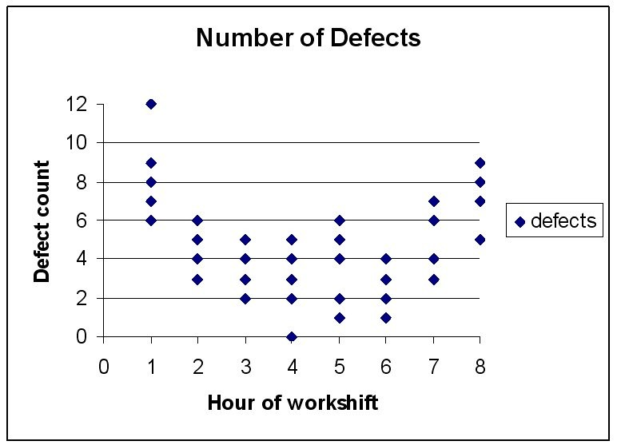

There is fairly convincing evidence that there are more defects in the first and last shift hours than at other times.
Diff: 2
Topic: Tools of TQM
AACSB: Analytic Skills
Objective: LO6-6
120) Perform a Pareto analysis on the following information:

Reason for unsatisfying stay at hotel | Frequency
Unfriendly staff | 6
Room not clean | 2
Room not ready at check-in | 3
No towels at pool | 33
No blanket for pull-out sofa | 4
Pool water too cold | 3
Breakfast of poor quality | 16
Elevator too slow or not working | 23
Took too long to register | 7
Bill incorrect | 3
Total | 100

Answer: Solution

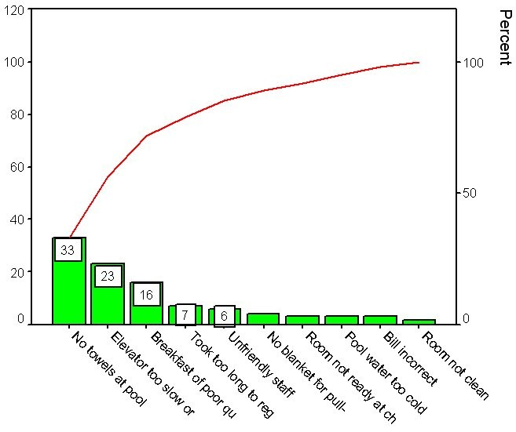
Diff: 2
Topic: Tools of TQM
AACSB: Analytic Skills
Objective: LO6-6
121) Perform a Pareto analysis on the following information:

Reason for unsatisfying check-out at store | Frequency
Unfriendly cashier | 27
Incorrect change | 4
Cashier too slow | 9
Price check | 34
Poorly bagged merchandise | 2
Slow receiving check approval | 3

Answer: Solution

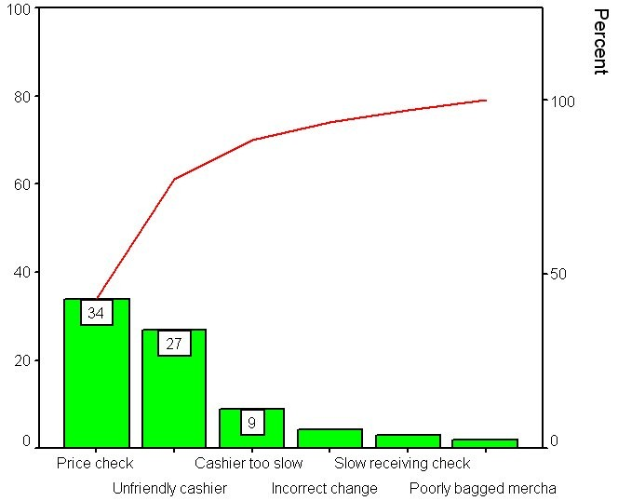

Diff: 2
Topic: Tools of TQM
AACSB: Analytic Skills
Objective: LO6-6
122) Construct a cause-and-effect diagram showing why a student might be dissatisfied with the cafeteria.
Answer: Solution: (Note that answers may vary considerably

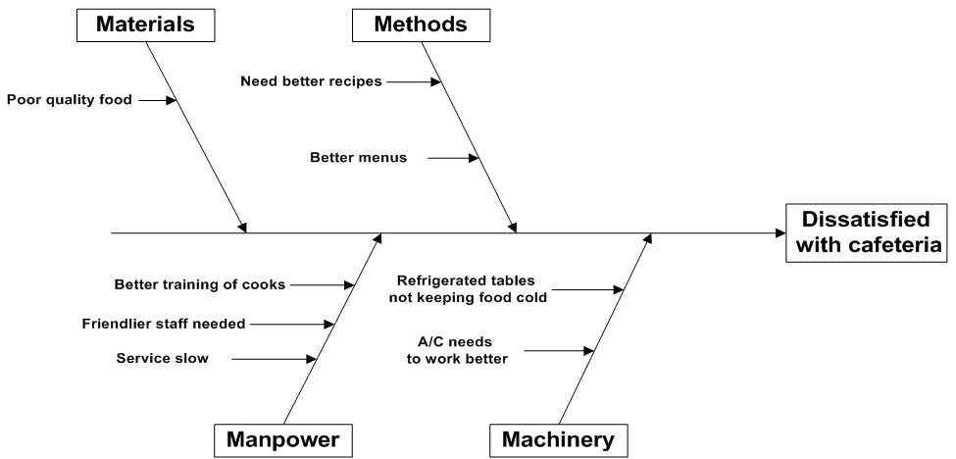
Diff: 2
Topic: Tools of TQM
AACSB: Analytic Skills
Objective: LO6-6

123) Pretend that you have just come from a relative's wedding reception. It didn't turn out as well as it should have, and the bride's parents are pretty mad at how things turned out. Use the supplied template to construct a conventional cause-and-effect diagram. Identify twelve sources of defects for the issue "dissatisfied customer of wedding reception caterer." (Your dozen need not be exactly three per main cause, but should be a balanced treatment.) Categorize each cause onto a main cause. Provide brief support for each of your choices.

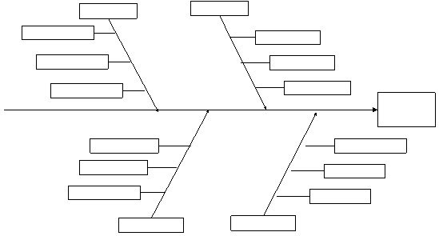
Answer: Solution: Individual responses may vary considerably; some of the variation in responses comes from differing views of what is the caterer's realm of responsibility, compared to what might be assigned to a wedding planner instead. Material: not enough plates, glassware, utensils; prepared wrong dish; food was cold; ran out of food; food was "bad." Machinery: air conditioning/heating was broken; room was dirty; room too small; furniture poorly arranged; wedding "props" ugly or shopworn. Method: not on time; overcharged; not enough workers. Manpower: wait staff not properly attired; wait staff not speedy; wait staff not courteous. Responses should comment as necessary to show why a fault lies on a certain main branch; as an example, "cold food" might be interpreted as Method, not Material.
Diff: 2
Topic: Tools of TQM
AACSB: Analytic Skills
Objective: LO6-6

124) A refrigeration and heating company–one that installs and repairs home central air and heating systems–has asked your advice on how to analyze their service quality. They have logged customer complaints. Here's a recent sampling. Use the supplied template to construct a conventional cause-and-effect diagram. Place each of the complaints onto a main cause; justify your choice with a brief comment as necessary. 1. "I was overcharged–your labor rates are too high." 2. "The repairman left trash where he was working." 3. "You weren't here when you said you would be. You should call when you must be late." 4. "Your repairman smoked in my house."5. "The part you installed is not as good as the factory original." 6. "Your repairman was here for over two hours, but he wasn't taking his work seriously."7. "You didn't tighten some of the fittings properly–the system's leaking." 8. "Your estimate of repair costs was WAY off." 9. "I called you to do an annual inspection, but you've done more–work that I didn't authorize."10. "Your mechanic is just changing parts–he doesn't have a clue what's really wrong." 11. "Your bill has only a total–I wanted to see detail billing." 12. "Your testing equipment isn't very new–are you sure you've diagnosed the problem?"13. "One of the workmen tracked mud into my living room."

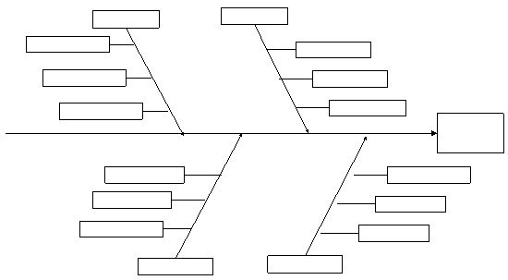

Answer: Solution: Individual responses may vary. A typical set of responses might be Material: item 5. Method: items 1, 3, 8, 9, 11. Machinery: item 12; Manpower: items 2, 4, 6, 7, 10, 13. Items 7, 8, and 11 could be manpower or method.
Diff: 2
Topic: Tools of TQM
AACSB: Analytic Skills
Objective: LO6-6
125) Construct a cause and effect diagram for why students arrive to class late. Include at least three reasons for each of the M's.

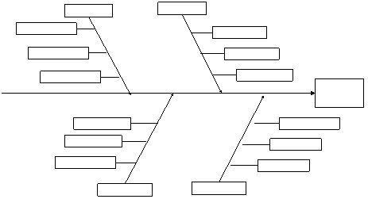
Answer: Student responses should look like the above, with the 4 M's of Manpower, Machinery, Method, and Material listed. Possible responses include: Manpower- not conditioned to waking up early, I can't wake up at the same time every day, I stay up late the night before sometimes Machinery- Car failure, Alarm clock reset from power outage, alarm clock turned off by roommate Method- forgot to set alarm clock, incorrect alarm clock setting (AM vs PM), I could not find the classroom Material- (these responses can be overlapped with machine answers to some degree) I wore flip flops so I could not walk fast, I could not find a sweater and did not want to go out in the cold, I lacked the proper materials for walking in the snow/ice.
Diff: 2
Topic: Tools of TQM
AACSB: Analytic Skills
Objective: LO6-6

126) A professor teaches two sections of a class, one on MWF for 50 minutes per day and another on T/TH for 75 minutes per day. Use the following information to construct a scatter diagram with test # on the x-axis and score on the y-axis. Should the professor argue for a change in the university's scheduling?

MWF Section Test Results Test # T/Th Test Results
75 1 82
70 2 77
65 3 73
65 4 70
70 5 76

Answer:
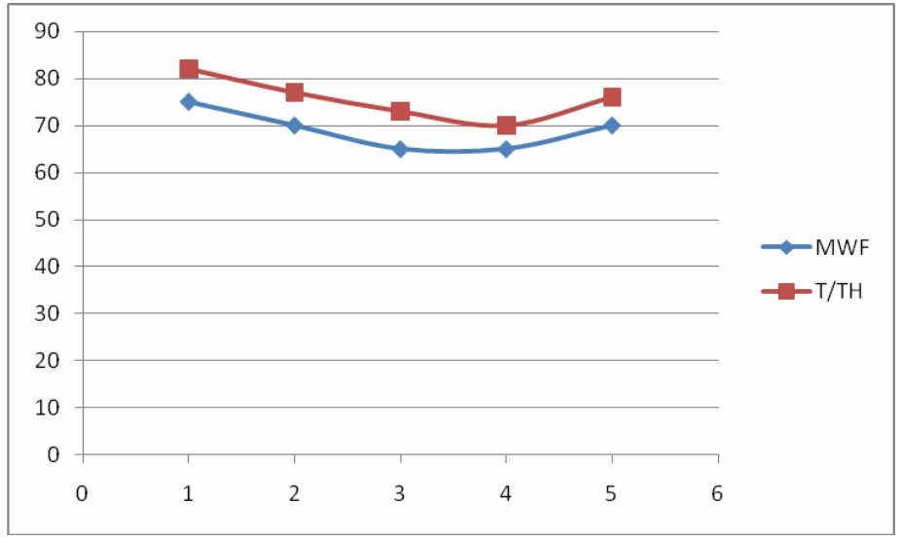

It appears that the T/TH section consistently scores higher than the MWF section. Perhaps the instructor should ask for MWF to be changed to MW with longer sessions, although the sample size is small.
Diff: 2
Topic: Tools of TQM
AACSB: Analytic Skills
Objective: LO6-6
127) Create a Pareto Chart for the following mistakes made in grading an exam.

Cause | Frequency
Incorrect Sum | 35
Question marked wrong was right | 3
Question marked right was wrong | 4
Partial Credit not consistent | 58

Answer:
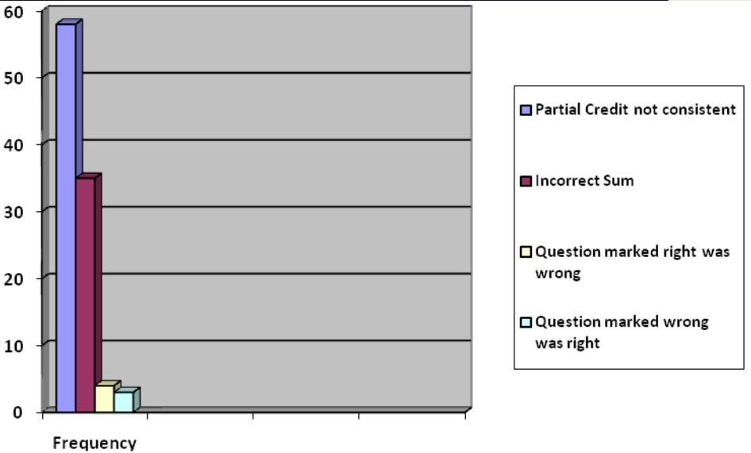
Diff: 2
Topic: Tools of TQM
AACSB: Analytic Skills
Objective: LO6-6
128) Construct a cause and effect chart for a missed field goal late in a football game with at least three aspects for each M.
Answer:
Responses should include the 4M's of Manpower, Material, Machine, and Method.
Student responses should fill out a diagram similar to the following.

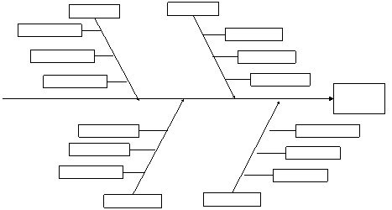

Possible responses include Manpower- Nervous mindset, Inconsistent offensive line blocking, lack of practice, Material(football)- ball was wet/slippery, ball was too worn/not worn in, ball was over/under inflated Machine (turf and field goal uprights)- uprights were slanted, uprights were too far away from the field (not positioned correctly), turf was wet/muddy, grass type was not correct Method- ball kicked too far to left or right, not kicked hard enough, kicker slipped on the kick, kicker did not hit the ball at the correct point, kicker aimed incorrectly. Other responses are acceptable as long as they mesh with under their associated M.
Diff: 2
Topic: Tools of TQM
AACSB: Analytic Skills
Objective: LO6-6
129) A pizza delivery company wants to improve its response time to gain a competitive advantage. Create a flowchart with 8 unique events from the time the customer calls in to the time the pizza is delivered.

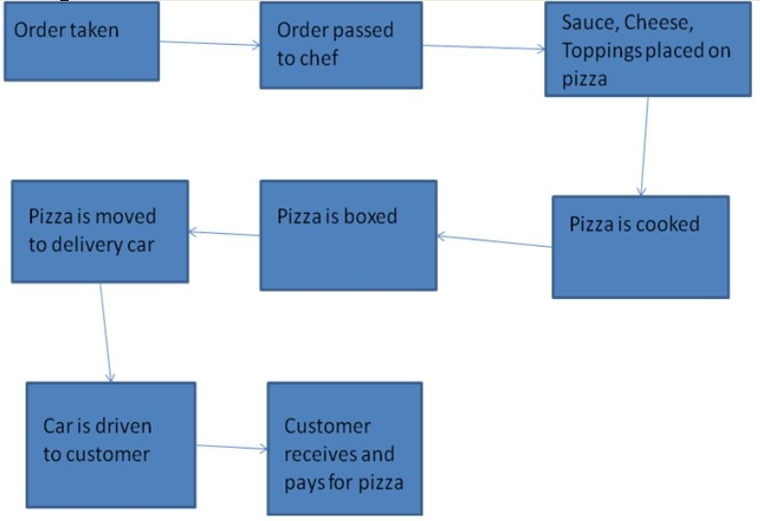
Answer: Student responses will vary but should follow a similar pattern. The flowchart will likely be in a single line, however any pattern is fine so long as the boxes are sequential connected with directional arrows.
Diff: 2
Topic: Tools of TQM
AACSB: Analytic Skills
Objective: LO6-6

